Name: Hafiz M. Muneeb Akbar
Roll No: SU92-BSAIM-F24-048
Subject: Programming for Artificial Intelligence (LAB)

Lab Task 6
Face-Based Personality Analyzer
Using OpenCV + Flask | MBTI Personality Detection

Project Overview
This project is a web-based application that analyzes a person's face from an uploaded photo and predicts their MBTI (Myers-Briggs Type Indicator) personality type. It uses OpenCV for facial feature detection and Flask as the web framework. The result is displayed on a clean web interface along with the uploaded image.

What is MBTI?
MBTI stands for Myers-Briggs Type Indicator. It categorizes personality into 16 types based on 4 dimensions, each with two possible values:
- E / I: Extraversion vs. Introversion
- S / N: Sensing vs. Intuition
- T / F: Thinking vs. Feeling
- J / P: Judging vs. Perceiving
Combining one letter from each dimension gives a type like INFP, ENTJ, ISFJ, etc.

Project Files
File | Purpose
app.py | Main Flask app — handles image upload and routing
profile_logic.py | Core logic — detects face features and returns MBTI type
camera_profile.py | Live webcam version — real-time face analysis using webcam feed
face_test.py | Test script — just detects and draws a box around the face
features_test.py | Test script — detects eyes and mouth on a test image
index.html | Frontend — upload form and result display page

How It Works
The system follows these steps when a user uploads a photo:
- User uploads a photo through the web interface (index.html).
- Flask (app.py) receives the image, saves it, and calls analyze_face() from profile_logic.py.
- The image is converted to grayscale for better detection accuracy.
- OpenCV's Haar Cascade classifiers are used to detect the face, eyes, and mouth.
- Based on the detected features, one letter is assigned for each MBTI dimension.
- The 4 letters are combined into a personality type (e.g., INFP, ESTJ).
- The result is sent back to the web page and displayed to the user.

Feature Detection Logic
Each MBTI dimension is determined by a simple rule based on face measurements:
Dimension | Feature Used | Rule
E / I | Eyes | 2 or more eyes detected = E (Extravert), else I (Introvert)
S / N | Face Width | Face wider than 150px = S (Sensing), else N (Intuitive)
T / F | Mouth | Mouth wider than 40% of face = T (Thinking), else F (Feeling)
J / P | Face Ratio | Height/Width ratio below 1.25 = J (Judging), else P (Perceiving)

Tools & Libraries Used
- OpenCV (cv2): Detects face, eyes, and mouth using pre-trained Haar Cascade classifiers.
- Flask: Python web framework that handles HTTP requests and renders the HTML page.
- Haar Cascades: Built-in XML files in OpenCV trained to recognize facial features.
- HTML / CSS: Frontend interface for uploading images and displaying results.

Two Versions of the App

1. Web App (Flask)
The main version. The user opens a browser, uploads a photo, and the personality result appears on the same page. The uploaded image is also shown for reference.

2. Live Camera (camera_profile.py)
A standalone script that uses the webcam in real time. It continuously analyzes the face in each video frame and displays the predicted personality type directly on the video feed. Press Q to quit.

Important Note
This project is rule-based and made for educational purposes. The personality type is determined by simple measurements of detected facial features — it is not a scientifically validated method. Real MBTI assessment requires a proper questionnaire.

Output Screenshot
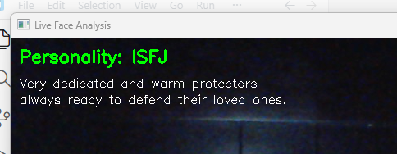
Figure 1: Live Camera

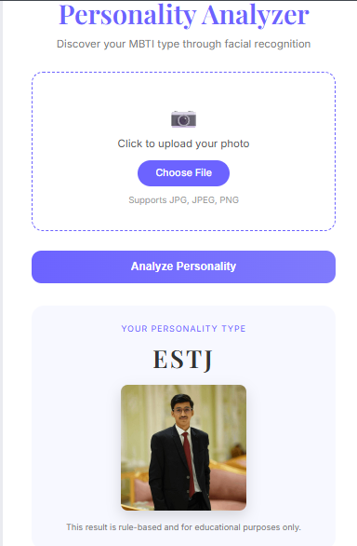
Figure 2: Web App (Flask)

